Vendor Packet for Junk’n at the Junction

June 15, 2019
9:00 a.m. – 3:00 p.m.

Buckstop Junction
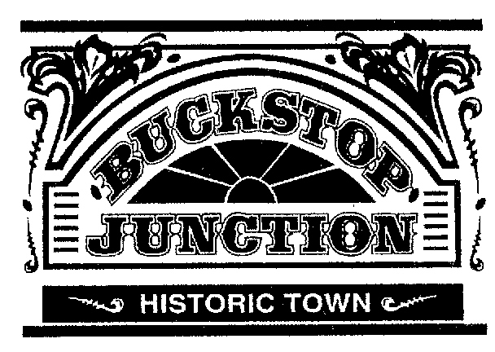
Located East of the intersection of Bismarck Expressway & East Main Avenue,
Bismarck, ND. (S. of I-94, Exit #161)
www.BuckstopJunction.org

This market features:
Antique, Vintage, Repurposed, Rescued, Up-cycled, Salvage, Shabby Chic

Join us at Junk’n at the Junction on June 15, 2019! Enclosed is information on becoming a vendor, the necessary qualifications and the required application. Each rental includes free admission for up to two people to work at your booth.
Upon readiness to reserve a spot at the event, call Brenda and Dani at (701) 425-2080 or e-mail us at junknatthejunction@gmail.com. Once your application is received, we will email you and let you know it was received. Starting April 1st we will send confirmation letters of acceptance for the booth space rental.
Junk’n at the Junction
Pricing
16 x 16 Booth Space - Outdoor | $75/day
Cancellations
To cancel your reservation, you must call (701) 425-2080. The cancellation deadline is 4 p.m. on JUNE 1st to qualify for a refund.

Merchandise & Weather Protection
Junk’n at the Junction will only close for severe weather. Your booth rental includes the space only; you are encouraged to protect your own merchandise.

Set-Up
Friday set-up hours are from 5 p.m. – 8 p.m. and 6 a.m.-8:45 a.m. on Saturday. Please arrive no later than 8:00 am. Access instructions for vehicles to bring in merchandise will be addressed in your acceptance letter. All vendor vehicles will need to be moved to a designated area by 8:45 a.m.

Parking
Limited parking is available outside the gates of the Buckstop Junction premises on a first-come, first-served basis.

Electricity
There is no power source available at Junk’n at the Junction. If you need electricity you must provide your own battery powered generator. Gas generators are not permitted.

Staying Informed!
Please follow Junk’n at the Junction on Facebook at www.facebook.com/junknatthejunction and our website www.junknatthejunction.wixsite/junk Questions: please call Brenda and Dani at (701) 425-2080 or e-mail us at junknatthejunction@gmail.com

Vendor Packet for Junk’n at the Junction
Buckstop Junction
Located East of the intersection of Bismarck Expressway & East Main Avenue,
Bismarck, ND. (S. of I-94, Exit #161)
Saturday June 15, 2019
Items for this market must fit one of the following categories:
Antique, Vintage, Repurposed, Up-cycled, Salvage, Shabby Chic

Vendor INFORMATION
Name:
Address: |  |  |  |  |  |  | Phone #
Home:
Cell:
City: |  |  | State: | ZIP Code: |  | E-Mail Address:

Business Information
Business Name: (if applicable)
Sales Tax Permit # (if applicable):
Website Address: |  |  |  |  | Facebook Page:
Please provide a detailed description of your business and items you plan to bring to Junk’n at the Junction
Please select the # of booths |  | Outdoor {$75} |  |  |  |  |  |  |  | X Multiple Booths {$75}
Total Enclosed $_____________________ Please make all checks payable to Junk’n at the Junction
Payment is due at time of application submittal of this form. Junk’n at the Junction will not hold any booths without full payment.
The undersigned hereby forever discharges, holds harmless and releases Junk’n at the Junction's volunteers and the MVHS at Buckstop Junction from any and all manner of action, claims, damages and/or suits, whatsoever arising out of any damage and/or loss to person and/or property of the undersigned while participating in these events.
 | Vendor signature: |  |  |  |  |  |  |  | Date:

Send completed Application, Reservation Fee to:
Junk’n at the Junction
2915 Emerald Place
Bismarck, ND 58503
Date Received:_____________

